Rx Laughter & Prince Mahavajiralongkorn
Cancer Center

Understanding the effects of humor therapy on

patient’s self-reports of pain, comfort, and anxiety

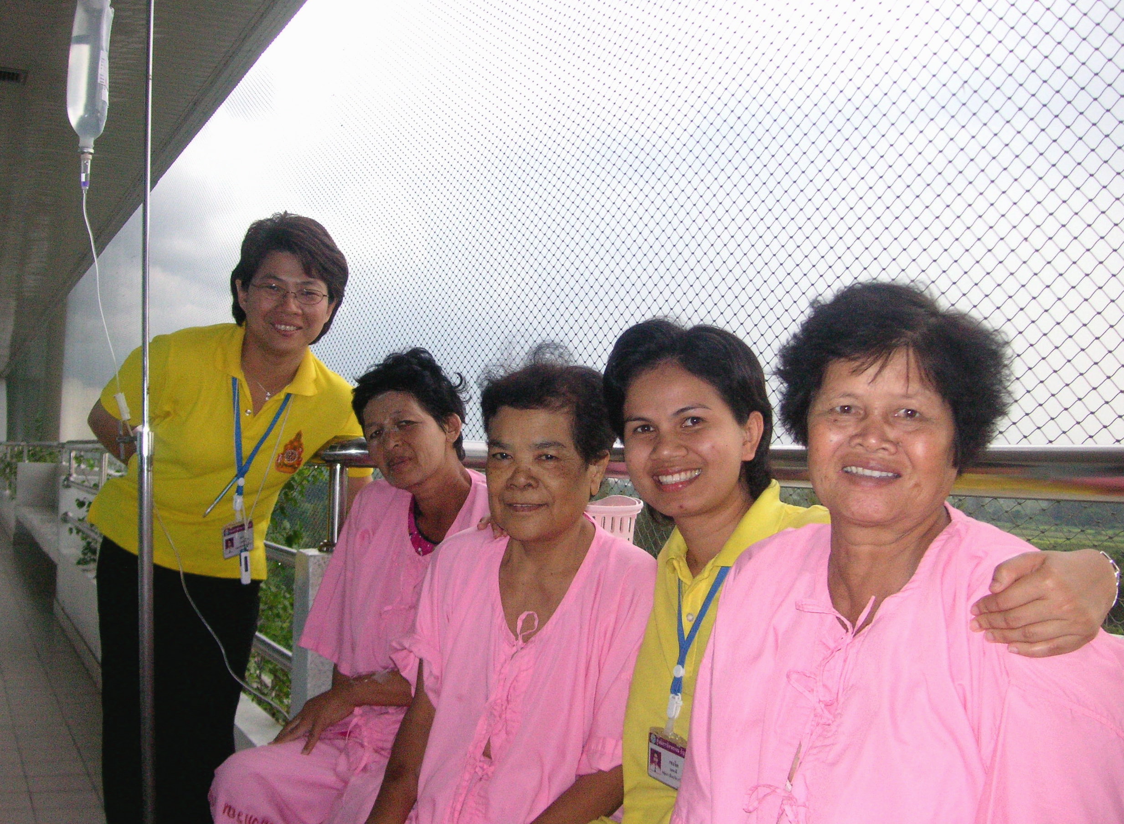

- Implications for enhancing patient care
- Applications for the improving patient wellness

Humor as a medium for non-invasive pain management

Pilot Project: January 2006 – 2007

Findings Summary: Prepared February 26, 2007.

Prepared by Satasuk Joy Bhosai and Saki Miwa of Yale University School of Epidemiology and Public Health and Sherry Dunay Hilber of Rx Laughter. Reprints not allowed without permission of Rx Laughter.

Evaluating the effects of humor therapy on patient wellness

Introduction
The aims of this study are to ascertain if humor, through the viewing of comedy movies and TV shows, positively affects the self-reporting of pain, comfort, and quality of life factors. Ultimately, this information seeks to understand ways in which humor may be integrated in the hospital setting to assist in enhancing the quality of life for patients. By examining this relationship, we are able to understand not only the applicability, but also the feasibility of humor therapy in the clinical setting.

The specific aims of this study were to gain insight on:
- An assessment of how humor therapy affects patients’ overall well-being
- The effect and applicability of humor therapy as a non-invasive medium for pain management.

Page 1 Rx Laughter & NCI Thailand
A collaborative research effort with the NCI of Thailand Page 2

Purpose
This study seeks to understand the applications of how humor therapy interventions can be used to enhance patient wellness in a variety of settings worldwide. Regardless of one’s social status, humor crosses all boundaries as a fundamental component of social cohesion and personal well-being. Thus, through such a universal medium, we gain insight into how humor therapy can be applied among a gamut of people—across generations, races, cultures, gender, and social classes.
By studying the use of humor therapy in cancer patients in Thailand, we gain information on how such interventions may be applied in any medical setting.
The study of humor and its applications has profound implications for how humor may be incorporated into the clinical setting in order to enhance patient wellness.

Methods
Patients were randomly assigned to either a control or a humor therapy group. Members of the therapy group received humor therapy, while members of the control group received no stimuli. Information on patients’ self-reports of pain, anxiety and comfort were collected through surveys, which were developed and approved by Rx Laughter and MCC. These surveys were distributed by the nurses of Ward 6.
Both control and therapy groups were given the same surveys and both initially filled out the survey before the intervention proceeded. This was to assess baseline self-reports that would later then be used for comparison. Each group was given the same survey to fill out at day 4 and again at day 7. Consequently, each participant in the study filled out the survey at 3 different points in time.
The therapy group was required to watch at least 2 hours of humor videos each day, once on the morning and another in time in the afternoon. It was required that each therapy participant view at least 10 sessions of humor footage during the entirety of the study. In total, the participants were required to watch 20 hours of footage.
Comedy footage used in the study was selected, with Rx Laughter’s agreement, by a pool of nurses who had informally interviewed the patients about what types of shows and movies they would prefer to see. The tapes were in Thai and were approved by the NCI as suitable programs for general viewing.
Statistical Analysis
Paired t-tests were used to obtain values for statistical significance. These tests were done to assess areas of statistical significance between the therapy and control groups for each outcome in the self-reported answers.

Page 3 Rx Laughter & NCI Thailand
A collaborative research effort with the NCI of Thailand Page 4

Our Patient Population

The study population was comprised of approximately 50 Mahavajirlongkorn Cancer Center (MCC) patients residing in Ward 6, an in-patient clinic. The clinic provides medical treatment and clinical care for cancer patients; however, due to a lack of resources, there are no psychological or emotional therapies available to help patients cope with their condition. Patients in Ward 6 are between 30-70 years old, with an estimated medium age of 56. The ward is occupied evenly between males and females. Most patients are enrolled in 30 BAHT, a governmental healthcare program that offers aid to the medically underserved.

Consents were obtained from all patients participating in this study. The consent forms include the intent of participation on behalf of the patient and also a disclosure clause to allow for the release of their health information for the purposes of our study.

Results: Pain
Overall, cancer patients who underwent the humor therapy self-reported statistically significant improvement in their pain scores in the following categories:
- overall pain
- the pain experienced after receiving cancer treatments
- the level of pain experienced at its worst
- the level of pain affecting their daily activities
While patients receiving the therapy reported improvements in their pain scores, the patients in the control group did not express similar improvements. In fact, the control cohort did not have a statistically significant improvement in their average pain score, except for a slight increase in the category of “pain at its worst.” Improvements among patients in the control group were not statistically significant.

Results: Overview
After undergoing the intervention, patients in the therapy group reported significantly lower levels of pain and anxiety than what they reported at the start of the study. They also reported a significantly greater level of comfort, satisfaction, and ability to fall asleep.
Therapy patients, in general, saw greater improvement in all measures compared to patients who did not receive the humor therapy. Cancer patients who did not undergo the intervention reported very little change in their pain, anxiety, and comfort/satisfaction levels during the time period studied.
It should be noted that at the beginning of the study, therapy patients reported greater levels of pain and anxiety, and lower levels of comfort, satisfaction, and ability to fall asleep as compared to those in the control group. However, at the end of the study, patients in both groups reported comparable levels for all measures.
This suggests that patients in the therapy cohort were initially worse off than patients in the control cohort, and that the humor therapy may have helped to improve patients’ pain, anxiety, and comfort/ satisfaction to levels similar to those experienced by the other patients.

Page 5 Rx Laughter & NCI Thailand
A collaborative research effort with the NCI of Thailand Page 6

Results: Anxiety
Cancer patients who received humor therapy reported significant improvements in their overall anxiety scores in the following categories:
- anxiety during treatments
- anxiety about their illness
- their ability to fall asleep.
Though the therapy cohort reported improvements in their anxiety scores, patients in the control group did not express similar improvements in their anxiety assessments.
The control cohort reported only slight increases in the improvement of their anxiety levels as compared to patients in the therapy group.
Additionally, patients in the control group reported increased difficulty falling sleep, as opposed to patients who received the therapy.
Nurses of Ward 6 qualitatively reported that humor therapy patients were able to sleep more comfortably and that patients were more amicable towards staff.

Results: Satisfaction and Comfort
The therapy cohort reported greater increases in their levels of comfort and in their satisfaction with the treatment and care that they received over the course of the study. Members of the therapy group also reported improvements in their patient satisfaction levels, while members of the control group reported a decrease in their levels.
Though patients in both therapy and control groups reported improvement in their comfort levels, the therapy cohort reported a higher overall improvement in their comfort level.

Page 7 Rx Laughter & NCI Thailand
A collaborative research effort with the NCI of Thailand Page 8

Discussion
The results of this pilot study suggest that humor therapy may have a significant impact on patient wellness. Humor therapy appears to significantly improve the pain and psychological outcomes of patients by decreasing levels of pain and anxiety, while increasing comfort, satisfaction, and ability to sleep.
Since the patients assigned to receive the therapy tended to report lower conditions than the control, it is unclear how much an increased ability to cope with their condition is attributed to time rather than the therapy itself.
Further research is needed to examine whether improvements in self-reported pain scores is either a function of one’s ability to cope with the illness over time, or rather that humor therapy attenuates pain and discomfort.
Based on the findings of this pilot study, the field of positive emotion research could benefit from future studies that explore specific areas of patient wellness. For example, a clinical trial could seek to evaluate if less pain medication is needed at nighttime, based upon these preliminary findings that humor therapy patients reported higher scores in their ability to fall asleep than patients in the control group.
Additionally, since patients reported increased satisfaction with hospital care, a larger study could examine if intrapersonal satisfaction or interpersonal relationships are improved through humor intervention.

Conclusion

Results of this study indicate that humor therapy could enhance patient wellness and satisfaction. This finding has implications for complementing clinical care.
Due to its cost-effective nature, humor therapy could be useful as a low-cost, non-invasive medium to reduce pain, anxiety, and promote comfort among individuals.
It also appears that humor has a positive effect on pain management, as patients self-reported less pain on a variety of scores. Therefore, humor may help improve clinical strategies of managing pain.
The success seen among cancer patients in Thailand implies that use of humor intervention can have value in terms of widespread clinical applications. It appears to not only be feasible in a low-cost setting, but also demonstrates that humor is a universal medium in which patients from a variety of backgrounds can benefit.
(Research Team & Acknowledgements: next & final page)

Page 9 Rx Laughter & NCI Thailand
A collaborative research effort with the NCI of Thailand Page 10

Prepared by Satasuk Joy Bhosai and Saki Miwa of Yale University School of Epidemiology and Public Health and Sherry Dunay Hilber of Rx Laughter. Reprints not allowed without permission of Rx Laughter.

Prepared: February 26, 2007

Acknowledgements to Research Team:
(alphabetical)

-Satasuk Joy Bhosai, Principal Investigator & Fulbright Scholar

-Sherry Dunay Hilber, Project Director & Founder of Rx Laughter

-Saki Miwa, Biostatistician, graduate student of Yale University.

-Khemachit Mookadee RN, Data Collections, (front page, far right)

-Dr. Tanadej Sinthusake, MD, MCC onsite Project Manager

-Khun Wanna RN, Data Collections (front page, far left)

This and other humor therapy projects developed and overseen by
Rx Laughter in collaboration with medical institutes are made possible in great part through an unrestricted grant by Comedy Central to Rx Laughter. Volunteer support was provided by the National Cancer Institute of Thailand.

Rx Laughter is a humor research, therapeutic, education and treatment 501c3 non-profit organization. For more information: www.rxlaughter.org.

Photos courtesy of MCC for Rx Laughter. No other usage is allowed.

Page 11

